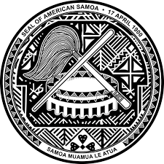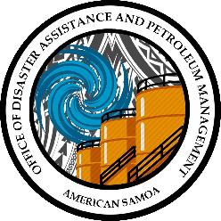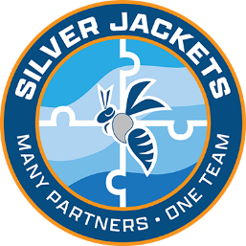

PRESS RELEASE

FOR IMMEDIATE RELEASE

OFFICE OF DISASTER ASSISTANCE AND PETROLEUM MANAGEMENT

AMERICAN SAMOA SILVER JACKETS TEAM IS OFFICIAL
SILVER JACKETS – MANY PARTNERS, ONE TEAM

AMERICAN SAMOA, July 24, 2023. The U.S. Army Corp of Engineers and National Silver Jackets program have determined that American Samoa Government has satisfied all the requirements to charter an American Samoa Silver Jackets Team. The American Samoa Silver Jackets team is now official. The government departments and agencies will form the American Samoa Silver Jackets team.
Under the direction of the Governor’s Authorized Representative (GAR), Honorable Lieutenant Governor Talauega Eleasalo Vaalele Ale and ODAPM Director Lisa Tuatoo, the American Samoa Silver Jackets Team has been established, and the GAR designated the ODAPM to take the lead in coordination of all the government departments and agencies participating in the program.
Why the name “Silver Jackets?” During disaster response, agencies are often identified by their color jacket or shirt. For example, FEMA wears blue jackets or shirts, and USACE wears red. Silver Jackets represent many partner agencies working together as one team to tackle mitigation and flooding issues.
Silver Jackets Mission: Deliver robust engineering solutions, in collaboration with our partners, to secure our Nation, energize our economy, and reduce disaster risk.
American Samoa is second to the last territory to join all 50 states and territories to become an official Silver Jackets member, thus updating the United States of America National Silver Jackets Map in July 2023. “Becoming an official team member of the Silver Jackets is quite an accomplishment for the Lemanu & Talauega administration and at such an opportune time while working on related requirements for the Tualauta and Fagaima drainage projects where repeat flooding issues need to be resolved,” said Director Lisa Tuatoo.
State and Territories Silver Jackets teams partner up to bring local agencies to learn from one another and work together to reduce risk from floods and sometimes other natural hazards. Silver Jackets teams conduct diverse collaborative efforts and focal areas as state and territory priorities vary. By applying their shared knowledge, the teams enhance preparedness, mitigation, response, and recovery efforts when such events occur. Resources for team activities are provided through individual programs of each participating agency.
The intent is not to duplicate existing teams but to supplement and strengthen current efforts and establish collaborative relationships where they still need to be created. The State and Territory Silver Jacket teams, are the forums where all relevant agencies collaborate to plan and implement interagency solutions. Through partnerships, teams optimize the multi-agency utilization of federal resources by leveraging state/local resources, which includes information, talent, and funding, while preventing duplication of effort. Leveraging multiple agencies' expertise, programs, and perspectives can result in more comprehensive and cohesive solutions.
Activities range from flood risk management lifecycle and promote shared responsibility. Team activities have included state hazard mitigation plan updates, inundation mapping, tabletop exercises, development of emergency action plans, risk communication workshops, and coordination of perishable data collection.
Although each state Silver Jackets team is unique, expected agency participants include state agencies with mission areas of hazard mitigation, emergency management, floodplain management, or natural resources conservation.
The American Samoa Silver Jackets Team’s federal participation includes the Federal Emergency Management Agency and the U.S. Army Corps of Engineers. The local participation consists of the Hazard Mitigation Council, which is chaired by the Honorable Talauega Eleasalo V. Ale, Lieutenant Governor and GAR, the Governor’s Office, Legislative Branch-Senate, Legislative Branch-House, Secretary of the Office of Samoan Affairs, Department of Commerce, Department of Port Administration, Department of Public Works, American Samoa Environmental Protection Agency, American Samoa Historic Preservation Office, American Samoa Power Authority, American Samoa Telecommunications Authority, Chamber of Commerce, American Samoa Department of Homeland Security, Department of Marine and Wildlife Resources, Governor’s Resilience Office and the Office of Disaster Assistance and Petroleum Management.

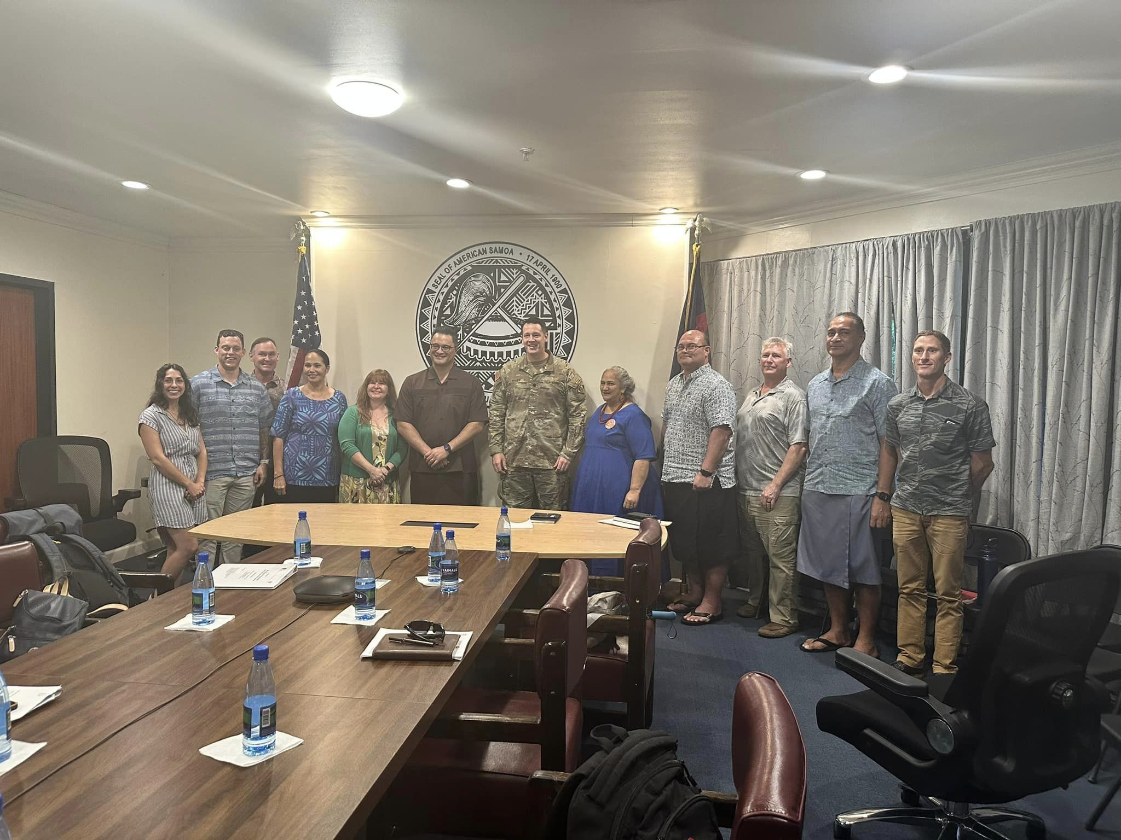
Hon. GAR Lt.Governor Talauega E.V. Ale, LTC Christopher Pevey, EPA Director Faamao Asalele, DMWR Director Taotasi Archie Soliai, ODAPM Deputy Director Salu Tuigamala, and USACE personnel
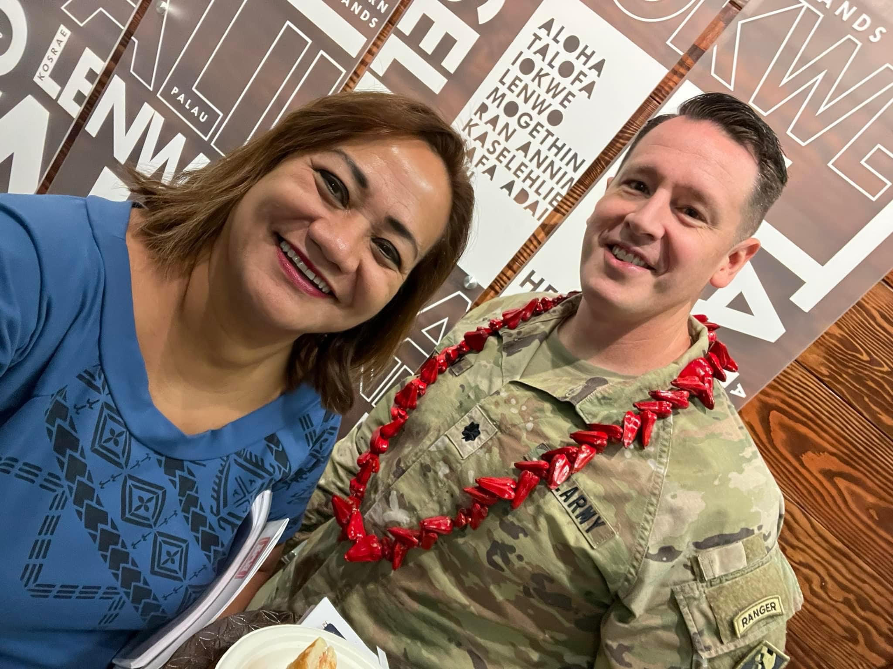
ODAPM Director Lisa Tuatoo and LTC Christopher Pevey

Office of Disaster Assistance and Petroleum Management
684-699-1330
odapm.as.gov
https://www.iwr.usace.army.mil/Silver-Jackets/

